COSC 236
Mock Exam # 1

- You have 2 hours to complete this exam.
- This exam is open-book/notes. You may not use personal computing or communication devices.
- This is a blackboard based exam and you may use the Dr. Java programming environment.
- Code will be graded on proper compilation, behavior/output and conformity to proper conventions.
- You may not access any applications other than Blackboard or DrJava during this exam.
Good luck!

Score summary:
Problem | Description | Earned | Max
1 | Debugging |  | 20
2 | Programming |  | 20
3 | Programming |  | 20
4 | Programming |  | 20
5 | Programming |  | 20
TOTAL | Total Points |  | 100
1. Find the Errors:
The following code contains many errors. The errors may be syntax, logic, or violations of conventions discussed in class. Copy this code into DrJava and make any necessary corrections to the code so that it compiles and produces the required output when run. Also, make sure that all naming conventions are followed.

// Calculates the area & circumference of a circle & return the area value
Public class CircleStats {

public static void main(String[] args) {
Scanner console = new Scanner();
int area = stats(console);
}

// This method prints the
public static String Stats(Scanner console) {
system.out.print("Enter the diameter of a circle: )
int diameter = console.nextDouble;
double radius = diameter/2;
System.out.println("For a circle with Radius =" + Radius);
System.out.println(" The circumference is: " + PI * diameter);
System.out.println(" and the area is: " + PI * radius ^ 2;
};
}

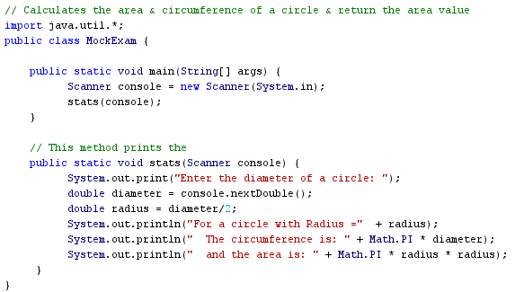

2. Programming
Write a static method named longestName that reads names typed by the user and prints the longest name (the name that contains the most characters) in the format shown below. Your method should accept a console Scanner and an integer n as parameters and should then prompt for n names.
The longest name should be printed with its first letter capitalized and all subsequent letters in lowercase, regardless of the capitalization the user used when typing in the name.
If there is a tie for longest between two or more names, use the tied name that was typed earliest. Also print a message saying that there was a tie, as in the right log below. It's possible that some shorter names will tie in length, such as DANE and Erik in the left log below; but don't print a message unless the tie is between the longest names.
You may assume that n is at least 1, that each name is at least 1 character long, and that the user will type single-word names consisting of only letters. The following table shows two sample calls and their output.
Call | Scanner console = new Scanner(System.in);  longestName(console, 5); | Scanner console = new Scanner(System.in);  longestName(console, 7);
Output | name #1? roy  name #2? DANE  name #3? Erik  name #4? sTeFaNiE  name #5? LaurA  Stefanie's name is longest | name #1? TrEnt  name #2? rita  name #3? JORDAN  name #4? craig  name #5? leslie  name #6? YUKI  name #7? TaNnEr  Jordan's name is longest  (There was a tie!)
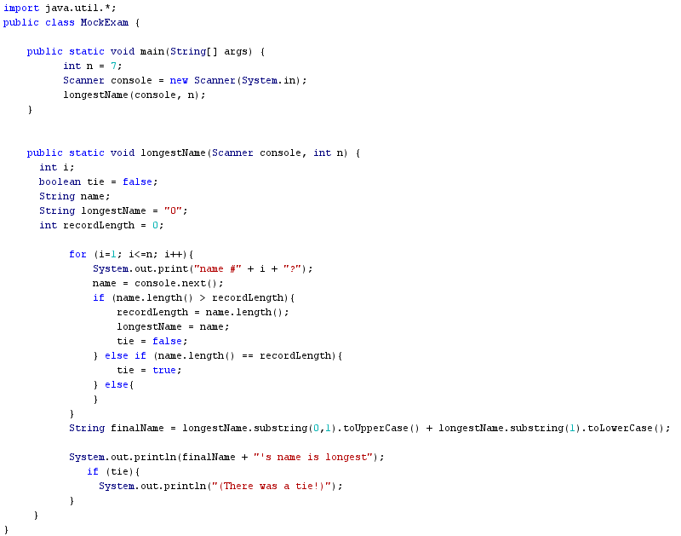3. Programming
Write a complete program that plays a coin flipping game, displays the individual flips, reports when a game is “LOST” or “WON” and shows the number of flips needed to complete the game.

The algorithm is as follows:
- Simulate the flip of a coin using a JAVA random number generator.
- Flip the coin once to initialize the flip value and print out the flip
- Inside of a loop, repeatedly flip the coin until 3 consecutive flips have the same value (3 heads or 3 tails)
  - Display the flip results after each flip
- When the game ends, report the total number of flips

Note: you can use 0 for heads and 1 for tails, but if you have time, add another method that will convert the integers 0 and 1 to the characters ‘H’ and ‘T’

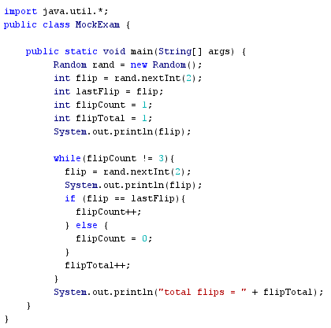

4. Programming
Write a static method named evenNumbers that accepts a Scanner from the console. The method should repeatedly prompt the user to enter integers until 3 consecutive even integers are entered. When 3 consecutive even numbers are seen, the method should output a message including the total number of entries.

You may assume that the user will enter a single integer after each prompt. Here is a sample dialog of user interaction with the program.

Looking for three even numbers in a row.

Type a number: 44
Type a number: 15
Type a number: 23
Type a number: 2
Type a number: 12
Type a number: 34

Three even numbers found after 6 total entries

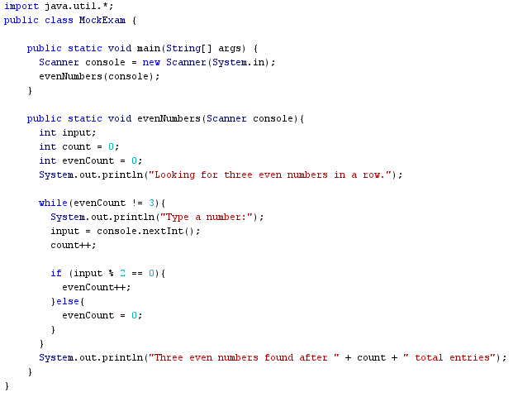
5. Programming
Write a static method named largerDigits that accepts two integer parameters a and b and returns a new integer c where each digit of c gets its value from the larger of a's and b's digit in the same place. That is, the ones digit of c is the larger of the ones digit of a and the ones digit of b, and the tens digit of c is the larger of the tens digit of a and the tens digit of b, and so on. You may assume that a and b are positive integers (greater than 0).
For example, suppose a is 603452384 and b is 921782. Their digits would be combined as follows to produce c:
a 603452380
b 920784
------------------
c 952784 (return value)
Notice that if a particular digit place is absent from one number or the other, such as the 603 at the start of a above, no digit is carried over to c. The following table lists some more calls to your method and their expected return values:
Call | Value Returned
largerDigits(172, 312) | 372
largerDigits(21, 3) | 3
largerDigits(90, 38906735) | 95
largerDigits(56002, 123321) | 56322
largerDigits(11223, 4466) | 4466
largerDigits(12345, 12345) | 12345
largerDigits(1, 34892) | 2
Hint: If you are building a result number, you may need to use Math.pow or accumulate a multiplier with each digit.
You may not use a String to solve this problem.

